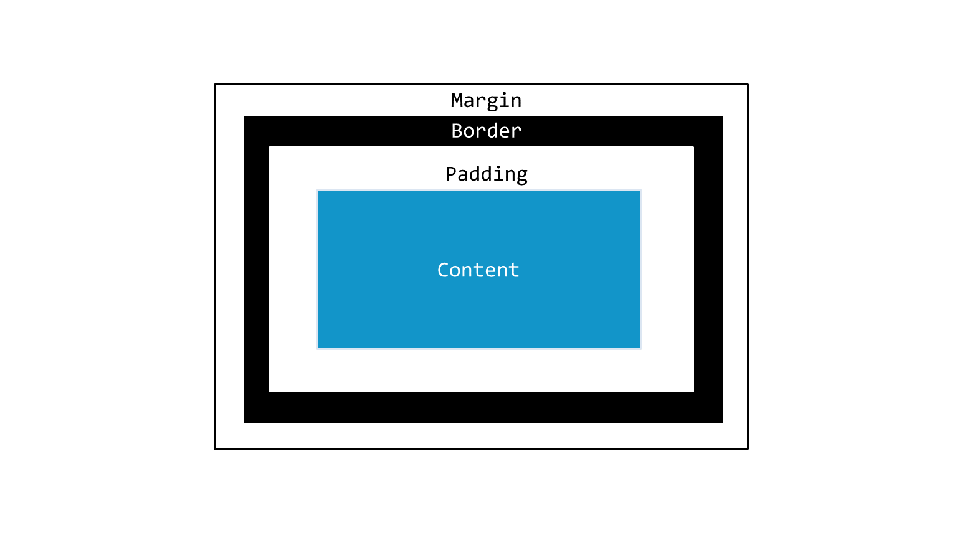
Box Model

Padding
- Padding sets a transparent space on all the sides of the content.
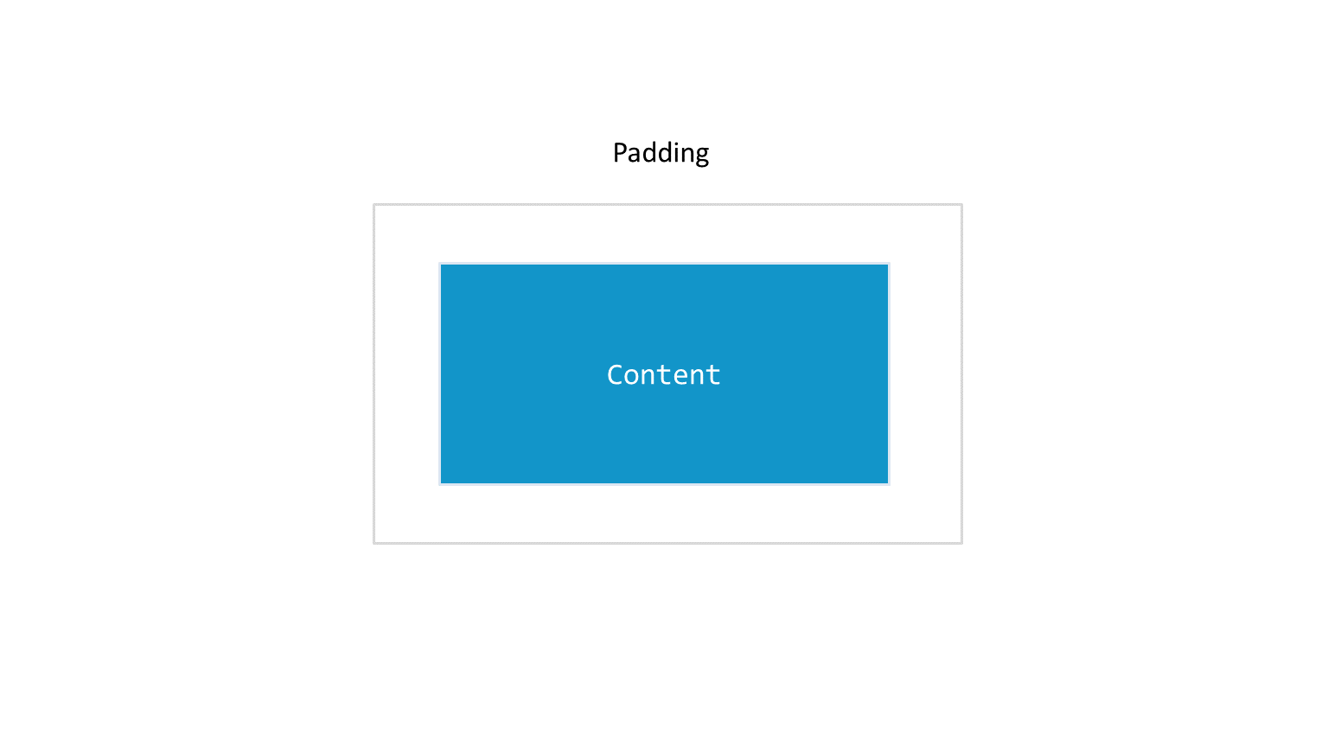

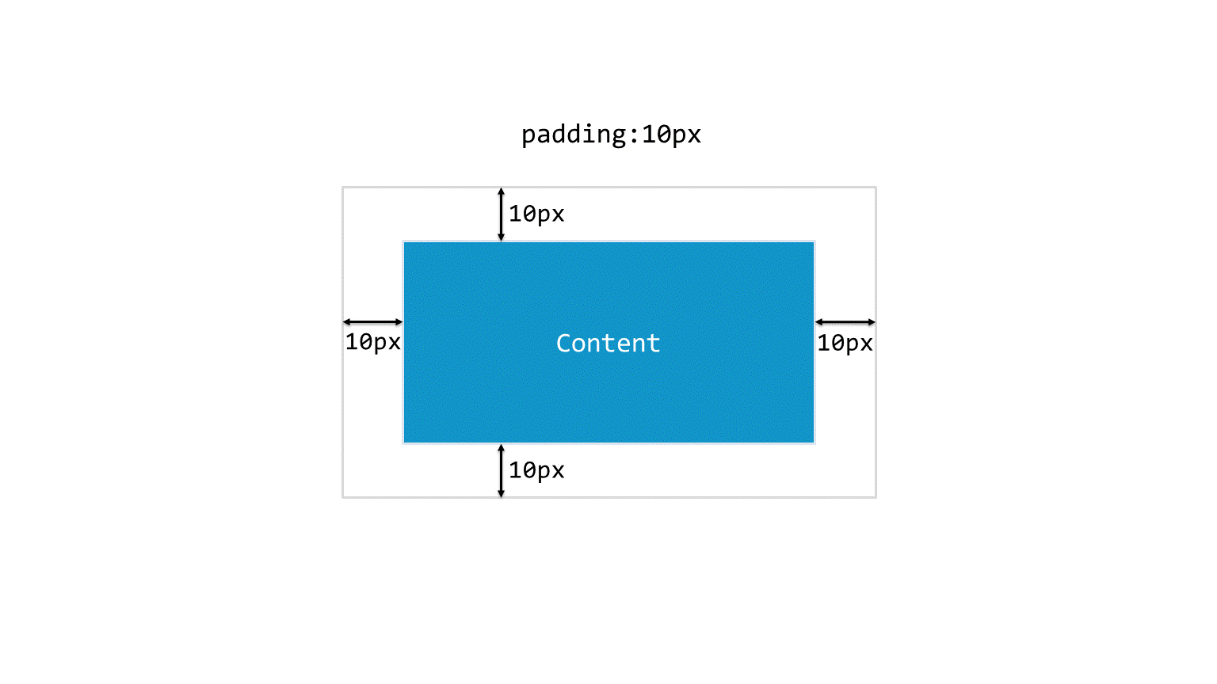
- We use padding property to specify how much padding we want to add on all the four sides of the content, like this padding: 10px;

This will clear 10px area on the top, left, bottom and right side of the content. This is called giving a padding to an element.

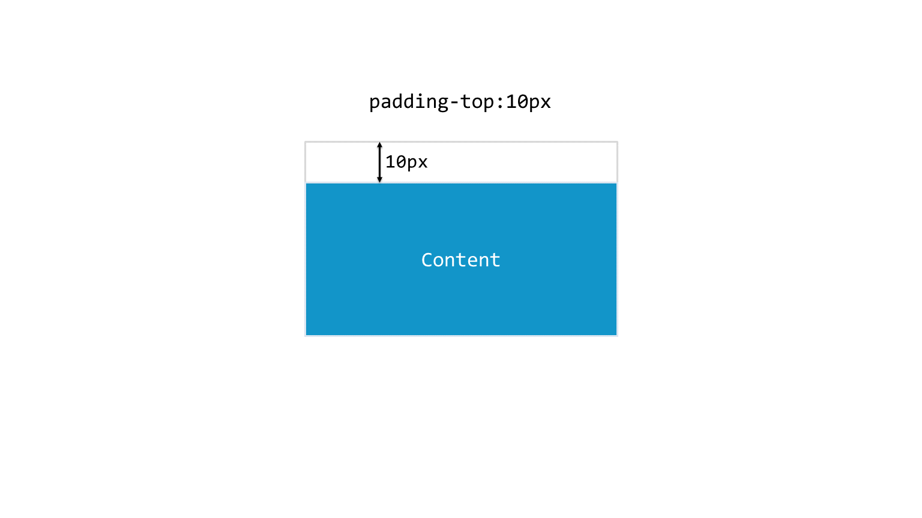
- If you want to add a padding of 10px only on the top you can use padding-top: 10px;

Similarly, you can add padding on left, bottom and right using padding-left, padding-bottom and padding left;
- You can use these properties in combination also, suppose you want to clear 10px on the top and bottom you can do it like this
  - padding-top: 10px; padding-bottom: 10px;
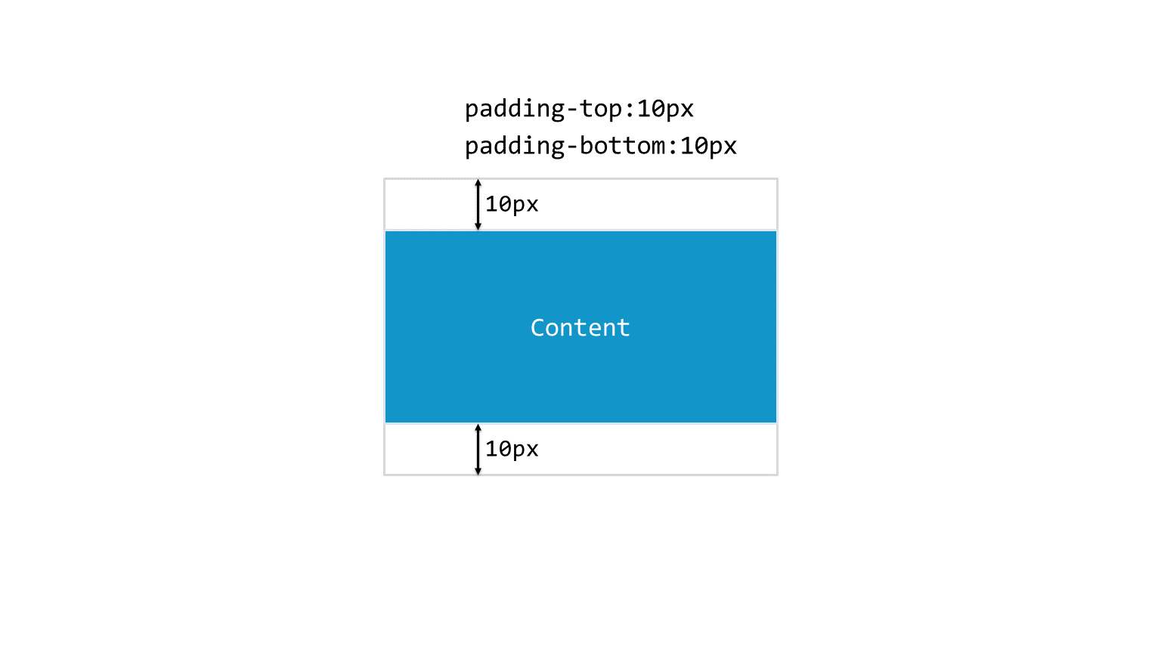

- You can mention this in a single line also using the shorthand property instead of using padding-top and padding bottom like this: padding: 10px 0px 10px 0px; This means padding: top right bottom left
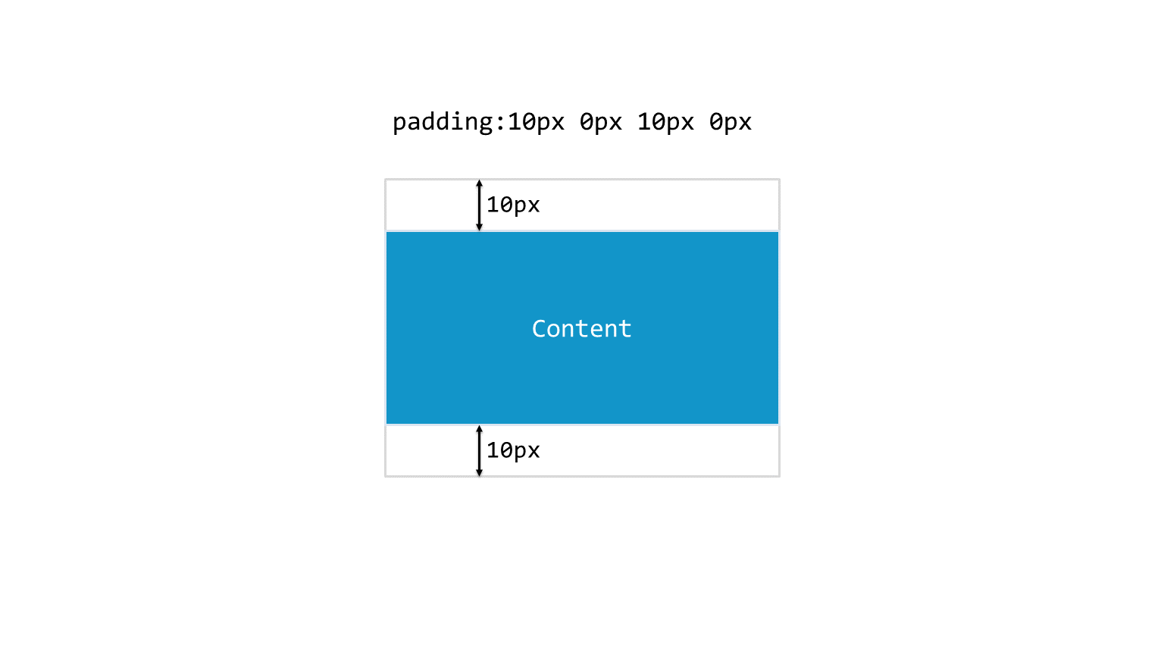
Shorthand properties are CSS properties that let you set the values of several other CSS properties simultaneously.
- These are the different ways to give a padding. Padding changes the dimensions of the content.

